2024 LINNEAN SOCIETY OF NSW NATURAL HISTORY FIELD SYMPOSIUM

NATURAL HISTORY OF THE NSW SOUTH COAST
Tuesday September 17, 2024 (oral presentations at Batemans Bay),
Wednesday September 18 & Thursday September 19 (field trips)

FIRST CIRCULAR
Scope
Over the past 13 years the Linnean Society of New South Wales has been active in organising a series of field symposia highlighting aspects of natural history in the Port Macquarie area (2010), Royal National Park (2012), Jenolan Caves (2013), Belubula Valley (2015), Snowy Mountains National Park (2017), Warrumbungles National Park (2018), Blue Mountains National Park (2019), and the Northeastern Sydney Basin encompassing Ku-ring-gai Chase National Park (2022). Focus of the 2024 field symposium will be on the South Coast of NSW and NE Victoria (Wollongong to Mallacoota) and the adjacent hinterland. Spectacular coastal outcrops in this region include some of the oldest rocks (upper Cambrian to Middle Ordovician) known in southeastern Australia, Upper Devonian rocks, together with the basal strata (Lower Permian) of the southern Sydney Basin. The botanical diversity is considerable, ranging from coastal heathlands to eucalypt forest with some of the largest known spotted gums. An initial day of scientific and general interest talks and presentations on current research into the geology and geodiversity, flora and fauna, and other aspects of the natural history of the entire South Coast region, will be held in Batemans Bay, to be followed by two day-long field trips extending south to Narooma and north to Ulladulla.

Costs and logistics
Venue for the day of presentations on Tuesday September 17 will be the Batemans Bay Soldiers Club (6 Beach Road, Batemans Bay) in the auditorium.
The registration fee (details shown on the attached Registration Form) will cover the venue hire, buffet lunch (vegan & gluten-free options available), morning and afternoon refreshments and the Program/Abstracts/field guide booklet. Registration will commence at 8.45 am with talks scheduled between 9.30 am – 4.30 pm.
The field trip fee each day will cover transport by 48-seat luxury coach with seat belts (all passengers seated). Those participating on the field trips are to provide their own lunch, snacks and beverages. The coach will depart from the bus zone adjacent to the Soldiers Club at 8.30 am and return there by 6 pm. Participants can register for any combination of the three-day sessions. As bus seats are limited (max. 48) for the field trips, preference will be given to those also registered to attend the day of talks. Early registration for the field trips is recommended.
Members of the Linnean Society of NSW will enjoy a modest discount on registration and field trip fees. Non-members are welcome to apply for membership of the Society to access these discounts. For details of membership categories and our low subscription rates, please refer to the website of the Linnean Society of NSW.
Cancellation policy: 50% refund will apply to cancellations notified up to and including July 31, 2024. No refunds will be given for cancellations notified after that date. Should it be necessary for the Society to cancel the symposium due to COVID-19 restrictions (or any other unforeseen events), we will return all monies paid by participants, less any administration costs imposed by the venue or bus company.

Accommodation in Batemans Bay and surrounding region
Registrants are to make their own accommodation arrangements. A wide variety of accommodation options suitable for all budgets are available in Batemans Bay and nearby villages to the south e.g. Batehaven. Other options within driving distance of the venue include numerous holiday parks with camping and cabin facilities on the coast north and south of Batemans Bay. NRMA members staying at holiday parks operated by this organisation can obtain discounted rates if staying for 4 nights or more (must book directly with the park or resort). Although the symposium is not being held in school holidays, the area is popular with visitors and intending participants are advised to book as soon as is practicable.

Proposed field trip itineraries
Wednesday September 18
The excursion will depart at 8.30 am from the bus stop opposite the Soldiers Club in Batemans Bay, and proceed south to Narooma. First stop will be at the southern end of Surf Beach nearly opposite Glasshouse Rocks, to inspect an outcrop of Ordovician-age Narooma Chert displaying spectacular zig-zag folds. Access will involve a scramble along a rough track through coastal casuarina bush to the beach, then a level walk of a couple of hundred metres along the beach (returning the same way).

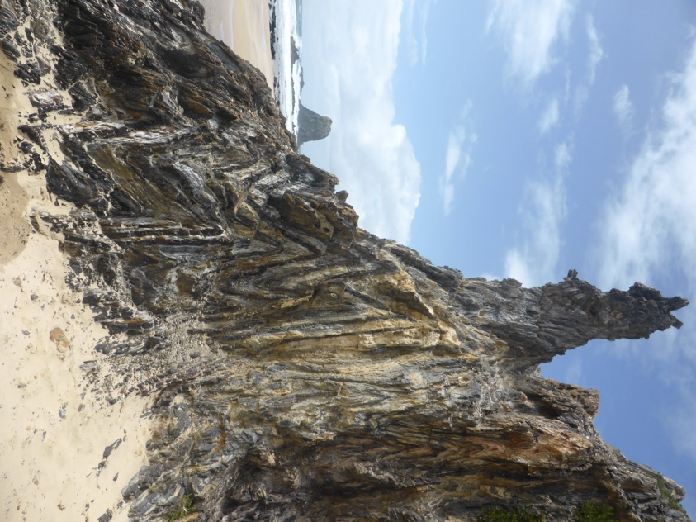
Zig-zag folds in an outcrop of Narooma Chert, which was originally deposited in horizontal layers on the ocean floor during the Ordovician Period.

We will then proceed to Bingie Bingie Point, on the coast north of Narooma. The walk from the car park is on fairly level but uneven ground, initially along a track but subsequently involving some rock-hopping. This spectacular outcrop is completely different from the first stop. It demonstrates intrusive relationships within the Devonian-age Moruya Batholith, with late-stage aplite dykes cutting xenolith-bearing granodiorite of the main intrusion. Dark-coloured basaltic dykes, related to the much younger Tasman Sea opening, cut across the older intrusive phases. Rock pools here provide opportunities to observe marine littoral zone algae and fauna.

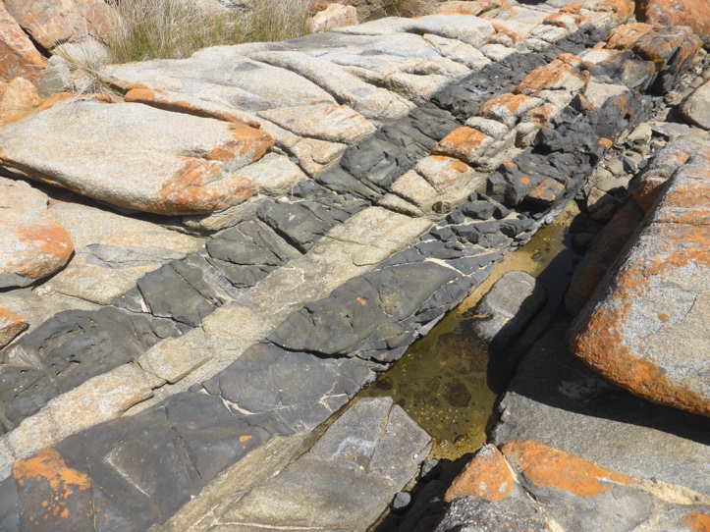

Basaltic dykes intruding granodiorite of the Moruya Batholith at Bingie Bingie Point.

After a short stop in Moruya to purchase and eat lunch, we will proceed to our next stop at Melville Point, Tomakin, on the northern side of the Batemans Bay estuary. There we will observe the unconformity between the Wagonga Formation (Ordovician-age turbidite deposits) and the Narooma Chert, and if time permits, structures interpreted as deformed pillow basalts, all indicative of a deep-water oceanic environment.
The final stop of the afternoon will be at Wasp Head, near South Durras. Access will initially be through the Murramurang Holiday Park where kangaroos laze around on the lawns. A short flight of stone stairs must be ascended to get to a bush track though coastal flora, leading to the rock platform opposite Wasp Island. The rocks here are among some of the oldest in the Sydney Basin succession, and are of Early Permian age. You will see numerous fossil shells interspersed with erratic pebbles and boulders derived from melting glaciers and ice floes.
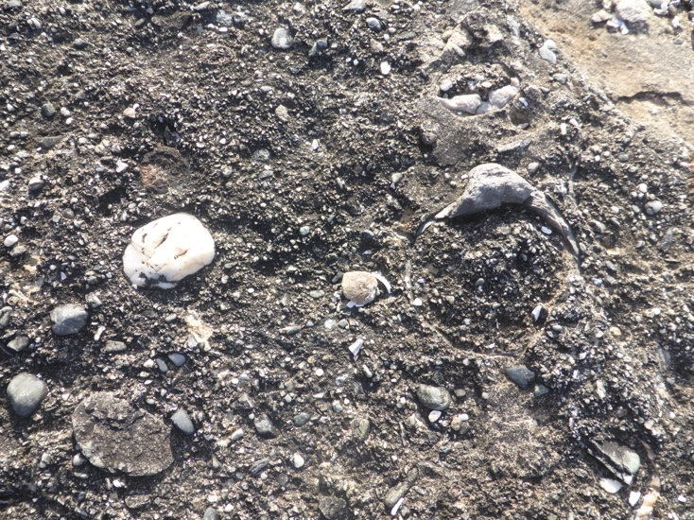

Fossil shells (brachiopods and a large bivalve mollusc, centre right of image) in a conglomeratic matrix dominated by dropstones (mainly rounded quartz pebbles here, but a variety of lithologies are present elsewhere on the rock platform) derived from melting ice floes. Wasp Head Formation of Early Permian age, deposited when Gondwana was near the South Pole.

We return to the Soldiers Club in Batemans Bay by 6 pm.

Thursday September 19
The bus departs at 8.30 am from the stop opposite the Batemans Bay Soldiers Club, for the drive north to Ulladulla. Our first stop there will be the Ulladulla Wildflower Reserve, where there will be the opportunity to meander on level well-formed walking tracks through woodland forest for about an hour. Spring is peak flowering season here and with any luck the waratahs should be in full bloom, together with several varieties of wattle, banksias, pea flower (Dillwynia), ti-tree (Leptospermum) and Lambertia. Native birds, particularly those feeding on seeds and nectar, are also plentiful here.
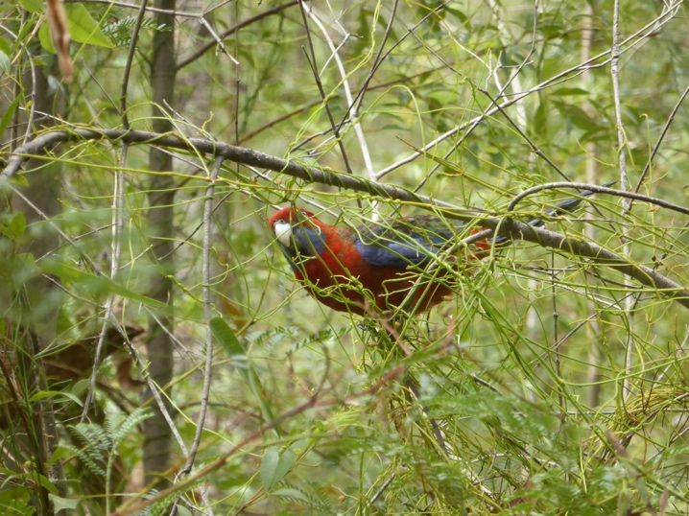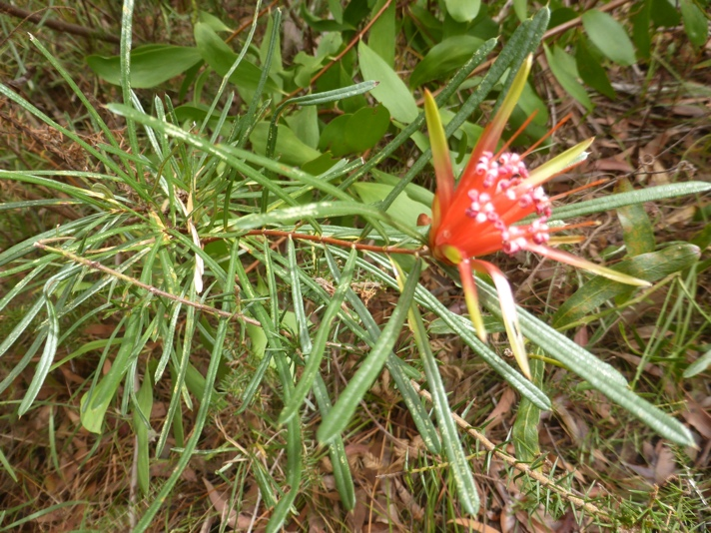
Next stop is the South Pacific Heathland Reserve to see a variety of coastal floral communities and their associated insects and birds. Among the plants in bloom will be banksias, conesticks, flannel flowers and grevillias. The Toothbrush Grevillia G. macleayii (which is restricted to the region between Nowra and Ulladulla) is a particular highlight of this Reserve. Outstanding views along the south coast are visible from several lookouts. About 1 hour 20 minutes is scheduled for this stop, to allow an unhurried walk along mostly level formed tracks.
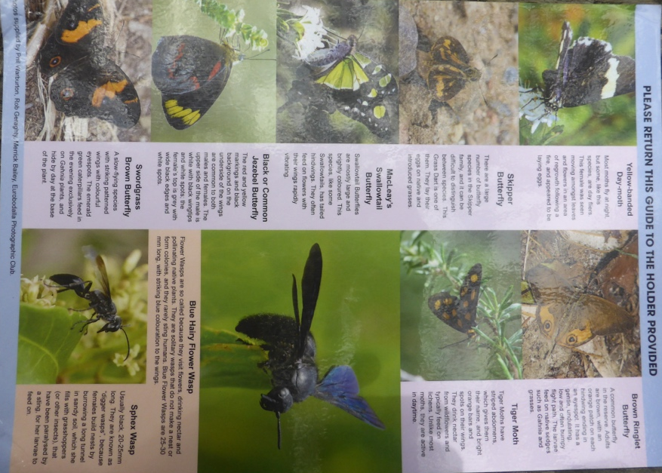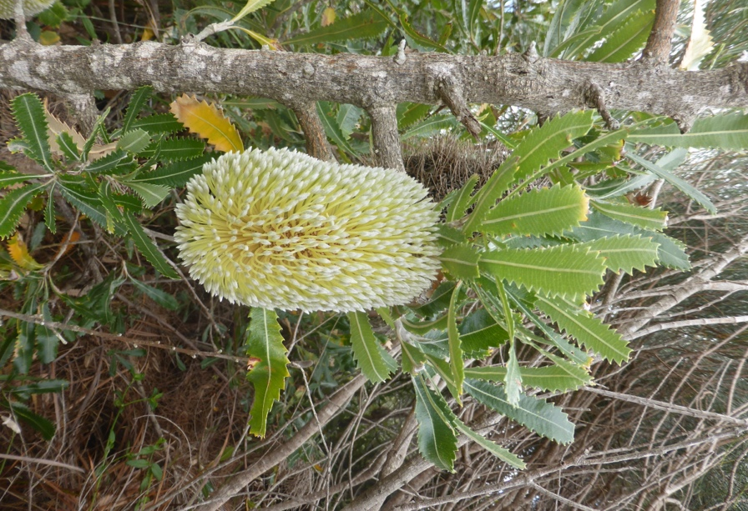
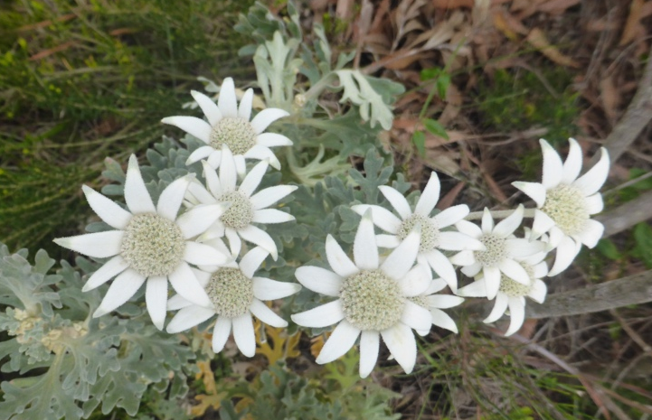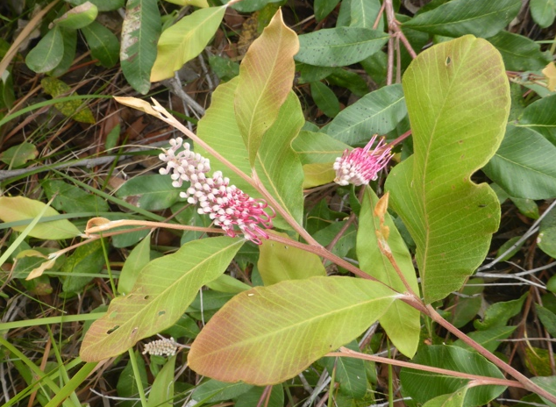
(Left): Flannel Flower Actinotus helianthi, and (right): Toothbrush Grevillia Grevillia macleayii
After a stop in Ulladulla to obtain lunch (which we will eat in a nearby park), we will make a brief stop at the Brodie Park Time Walk, which sets in context all the significant rock types and their ages on the South Coast. By this time the tide will have dropped sufficiently for us to enjoy a walk (1.5 – 2 hours maximum) along the rock platform at Ulladulla Harbour, where we will see highlights of the Gondwana Coast Fossil Walk, including Permian fossils and associated geological features. These rocks, although Permian in age, are quite a bit younger than those observed at Wasp Head and were deposited in a different sedimentological environment.
We then depart Ulladulla and head south just beyond Termeil, where we plan to view “Old Blotchy”, the second-largest Spotted Gum in NSW. Its impressive dimensions are height 59 m, girth 10.8 m, diameter nearly 3 m. It is estimated to be about 500 years old. The bus will park beside the Princes Highway and we will need to walk in and back along a mostly level forestry road, approximately 1.4 km each way.
We return to the Soldiers Club in Batemans Bay by 6 pm.

Call for presentations
The Linnean Society of NSW invites anyone involved in research (be it formal scientific studies or citizen science) into, or an active interest in, any aspects of the natural history of the South Coast region from Wollongong to Mallacoota, to present their results at the Symposium. Focus will be principally on the geology, botany and zoology of the region’s national parks, conservation areas and other reserves, and coastal rock platforms in the area bounded by the coastline to the east, with the ranges of the hinterland forming the western boundary. Aspects of planning and management related to environmental matters will also be covered. Presentations on regeneration of the region’s flora and recovery of its fauna following recent catastrophic bushfires are welcome.
The day of talks is anticipated to include up to 20 presentations of 15-20 minutes duration on various scientific subjects relating to geology/ geomorphology, botany, zoology, anthropology and conservation science of the South Coast region. Invited keynote speakers will introduce these and other topics in 30 minute talks. Powerpoint facilities are available. Submissions from researchers, citizen scientists and students interested in presenting should be advised as soon as possible. In general, a maximum of one presentation per registered speaker is permitted, although additional talks may be considered if time permits. Decision to accept a presentation will be at the discretion of the convenors of the Symposium.

Abstracts
Please use the abstract template (included below) and adhere to the instructions provided. Abstracts (including illustrations if any) are limited to a single page and will be included in the Program/Abstracts/Field Guide booklet distributed to registrants. Abstracts are due by July 31. Submit abstract to secretary@linneansocietynsw.org.au. At least one of the authors must be registered to attend the symposium. Decision to accept any abstract is entirely at the discretion of the convenors of the Symposium.

Publication of papers presented at the symposium
Papers presented at the symposium are invited to be submitted (though this is not mandatory) for publication in the Proceedings of the Linnean Society of New South Wales, subject to editorial standards and peer review. This journal, first published in 1874, is available online and is open access, and has no page charges (even for colour figures). A detailed set of Author Guidelines is available on the Linnean Society of NSW website. Deadline for submission of manuscripts will be April 30, 2025 with publication likely in mid to late 2025. Accepted papers are published as soon as they are edited and proofed.

For further information, please contact
Linnean Society of NSW office: secretary@linneansocietynsw.org.au

ABSTRACT TEMPLATE
Title text in bold Times New Roman 14 pt left justified
Oscar Seniorauthor^{1,2}, Lucinda Coauthor¹ and John J. Juniorauthor³
¹ Affiliation 1
² Affiliation 2
³ Affiliation 3
Abstract text here (abstract is limited to one A4 page including any figures or photographs as JPEGS). Use 12pt Times New Roman font throughout for authors, affiliations and abstract text. Multiple line spacing at 1.15. Underline name of presenting author. Check spelling prior to submission. Abstract text here (abstract is limited to one A4 page including any figures or photographs as JPEGS). Use 12pt Times New Roman font throughout for authors, affiliations and abstract text. Multiple line spacing at 1.15. Underline name of presenting author. Check spelling prior to submission. Abstract text here (abstract is limited to one A4 page including any figures or photographs as JPEGS). Use 12pt Times New Roman font throughout for authors, affiliations and abstract text. Multiple line spacing at 1.15. Underline name of presenting author. Check spelling prior to submission. Abstract text here (abstract is limited to one A4 page including any figures or photographs as JPEGS). Use 12pt Times New Roman font throughout for authors, affiliations and abstract text. Multiple line spacing at 1.15.

REGISTRATION FORM

Name (please print): E-Mail:

Phone number:

Affiliation or address:

Fee category (please circle): Full member of the Linnean Society of NSW / Student member / Retired member / Non-member

Up to July 31, 2024** After July 31, 2024

Fee Category | Scientific Session Sept 17 | Field Trip Sept 18 | Field trip  Sept 19 |  | Scientific Session Sept 17 | Field Trip Sept 18 | Field trip  Sept 19
Students | $58.00 | $30.00 | $27.00 |  | $68.00 | $40.00 | $37.00
Retired, & Associate Members | $60.00 | $32.00 | $28.00 |  | $70.00 | $42.00 | $38.00
Full Members | $65.00 | $33.00 | $30.00 |  | $75.00 | $43.00 | $40.00
Non-members | $85.00 | $45.00 | $40.00 |  | $100.00 | $60.00 | $55.00
**registration fees must be received by this date to obtain Early Bird discount.

Please send completed registration form to
- secretary@linneansocietynsw.org.au as an attachment (indicate date & method of payment), or mail to
- Linnean Society of New South Wales, PO Box 291, MANLY NSW 1655.

Payments to be made by:
- Bank transfer: St George Bank. Account name “Linnean Society of NSW”
BSB 112-879, Account 466447867. Please label payment ‘SCS_yoursurname’
- Cheque made out to The Linnean Society of NSW, posted to the above address.
Note that the Society does not have credit card or BPay facilities.
Participants must make their own travel and accommodation arrangements. Please notify any special dietary requirements (e.g. vegetarian, gluten-free) for Sept 17.
Participants must provide their own lunch (& snacks & drinks) for the field trips on Wednesday, September 18 and Thursday, September 19.

